**Issues with installing Trimble License Manager**

1. Make sure you have ***FULL ADMIN*** rights
2. Run the ***Trimble License Manager executable***
3. If it hangs up during installation and fails then try the following. ***Don’t hit CANCEL***
4. Go to ***Control Panel***
5. Select ***Administrative Tools***
6. Click on ***Services***
7. Scroll down to the ***Trimble Mapping & GIS License Service***
8. ***Right Click*** on it and select ***Properties***

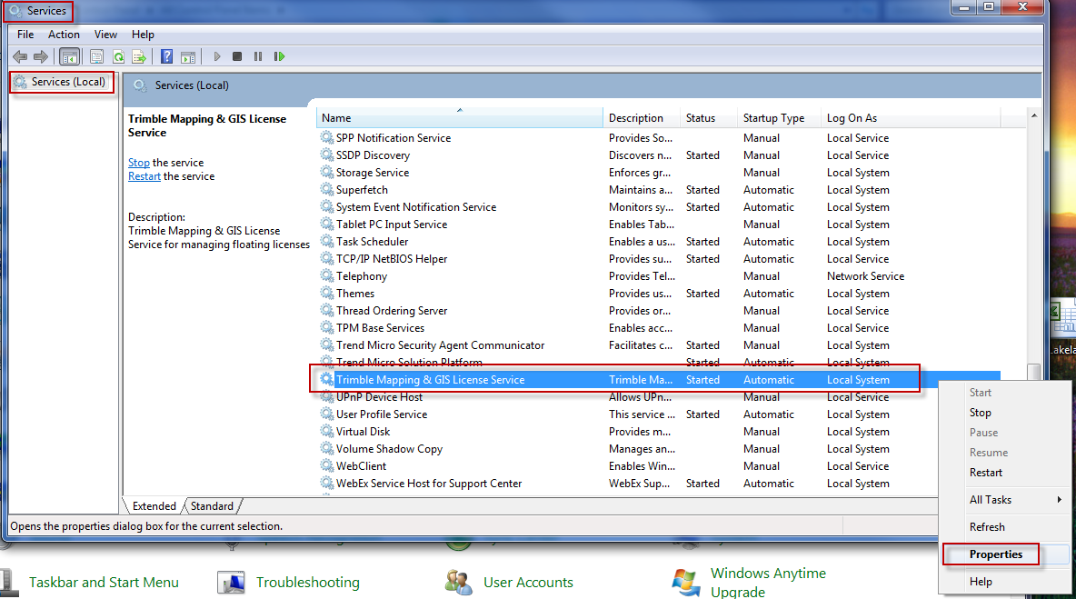

1. Click on the ***Log On*** tab
2. 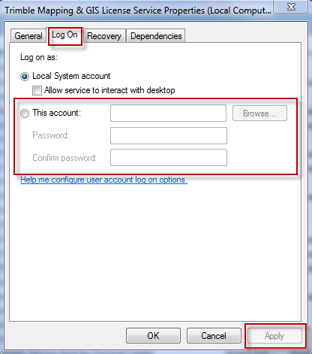Change ***Local System*** account to ***This account***
   1. ***Enter*** a FULL Admin user account
   2. ***Enter*** Password
   3. ***Re-enter*** Password
   4. Click on ***Apply***
   5. Click on ***OK***
3. ***Start*** the License Service
4. Go back to the install wizard
5. Select ***Retry*** on the install Error
6. If the software installs properly then you have different settings between the ***local account*** and the “***this account***” and you should check with your IT to get this resolved.